Contents

Glossary 1

Ligand 1

Cationic lipids 1

pKa 1

Oligonucleotides 1

Literature Review 2

What is Microfluidics? 2

Application Fields 2

Biology: Lipids and Carriers 2

Lipid Nano Particles (LNP’s) 4

In Detail – The Role of Four (Ionisable) Lipid Components of LNPs 5

LNP Synthesis 8

# Glossary

#### Ligand

An ion or molecule with a functional group that binds/is sticky. These functional groups can be attached to liposomes to enhance drug delivery to specific cells or tissues.

#### Cationic Lipids

A positively charged molecules that commonly bind to negatively charged nucleic acids, amphiphilic in nature (meaning they have both hydrophilic and hydrophobic parts) used frequently in the delivery of genetic material like DN and RNA into cells.

#### pKa

Base-10 logarithm of the acid dissociation constant (Ka) of a solution. It is a way of quantifying the strength of an acid; a lower pKa value indicates a stronger acid. The acidity constant (Ka) = concentration of products / concentration of reactants. pKa = -log(Ka)

#### Oligonucleotides

Short, single- or double- stranded sequences of DNA or RNA typically ranging from 2 to 25 nucleotides in length.

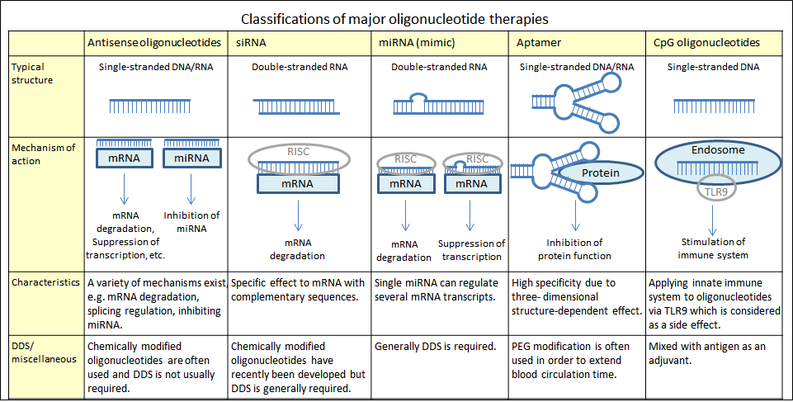

#### Transfection Rate

Transfection is the process of introducing nucleic acids (DNA or RNA) into cells using methods other than viral infection. Transfection rate/efficiency refers to the percentage of cells in a population that successfully take up foreign nucleic acid (DNA or RNA) during a transfection experiment.

# Literature Review

### What is Microfluidics?

Microfluidics is the application of science and technology to manipulate tiny fluid volume (nanolitres to microlitres) in microscale channels. This allows complex lab functions to be scaled down and simplified, know as “lab-on-a-chip”. Such small fluid flow has characteristic physics. These include predominantly laminar (non-turbulent) flow and precise temporal and spatial control of fluid movement. The benefits are plentiful, but the most significant are that microfluidics: reduce sample and reagent consumption cost, can be used for customisable point-of-use application, can integrate multiple laboratory steps on a chip and allow the rapid development of a process line for fast analysis.

### Application Fields

Microfluidics exist in a broad range of fields, including; biomedical; pharmaceutical; environmental and food monitoring; chemical analysis/synthesis and industrial or university research. For this literature review, the use of microfluidics in the synthesis of nanoparticles and lipid carriers for pharmaceuticals will be the only focus.

### Biology: Lipids and Carriers

<https://en.wikipedia.org/wiki/Lipid>

<https://en.wikipedia.org/wiki/Lipid_bilayer>

<https://en.wikipedia.org/wiki/Lipid-based_nanoparticle>

Lipids are a broad range of organic compounds which include fats, phospholipids, waxes and others. There function include storing energy, signalling and acting as structural components of cell membranes. Fatty acids contain ipids. They form structures such as liposomes (artificial) or vesicles (natural structure). Liposomes is the double bi-layer molecule that can hold specific substances

|  |  |  |
| --- | --- | --- |
|  | A membrane bilayer and liposome. | Download Scientific Diagram | A) The liposome is a spherical lipid bi-layer (bi-layer of polar... |  Download Scientific Diagram |

The bi-layer is usually impermeable to most water soluble (hydrophilic) molecules, meaning that ions and proteins don’t diffuse in our out. These biological bi-layer are usually composed of phospholipids, containing a hydrophobic tail and hydrophilic head. The tail determines the thickness and phase of the bilayer e.g. a higher cholesterol concentration induces a liquid-ordered (Lo) phase, which is described as a gel phase but with increase lateral mobility similar to a liquid-disordered phase. Additional, phase is determined by temperature, with it being a solid gel phase at a low temp but a fluid state at higher temperatures. Since cholesterol increases membrane ridgidity, it reduces drug leakage from the liposomal core, essential for encapsulating nucleic acids.

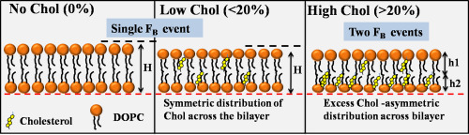

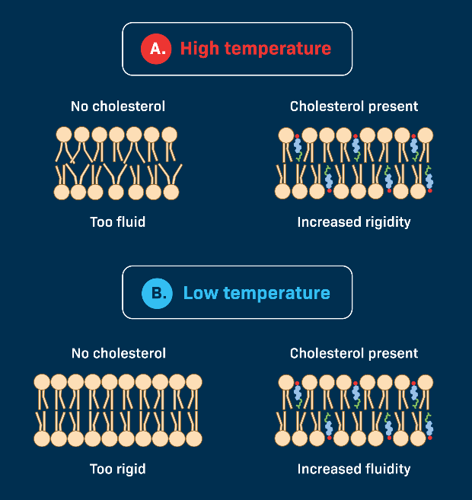

### Lipid Nano Particles (LNP’s)

<https://en.wikipedia.org/wiki/Lipid-based_nanoparticle>

LNPs is one of the emerging fields of lipid nanotechnology for clinical medicine, research and drug delivery. In the pharmaceutical industry, the drug solution is encapsulated inside the liposome and then injected into the patient. The drug-loaded liposome travel through the system until they bind at the target site, rapture and release the drug. The first generation of Lipid Nano Particles (LNP’s) suffered from being too sensitive to phagocytosis and renal clearing. Resulting Polyethylene glycol (PEG) coating were applied to the liposome surface, producing ‘stealth’ vesicles. This allows them to circular over long period times without immune or renal clearing. This means their will be a larger amount of PEG-LNP’s in the body in a first dose, compared to LNP’s, meaning when there is a effector chemical that is introduced into the body later in time, the PEG-LNP will have a stronger effect. LNP’s were recently used in COVID-19 RNA vaccine technology (Moderna and Pfizer); coating the fragile mRNA strands with PEG-LNP’s as their delivery vehicle. Keep in mind, PEG’s can have downsides, such as Accelerated Blood Clearance (“ABC Phenomenon”) or “PEG dilemma”, hindering the interaction with target cells. LNP’s have also been used in cancer treatments as their angiogenesis (growth/reproduction) behaviour makes them ‘leaky’, allowing in liposomes.

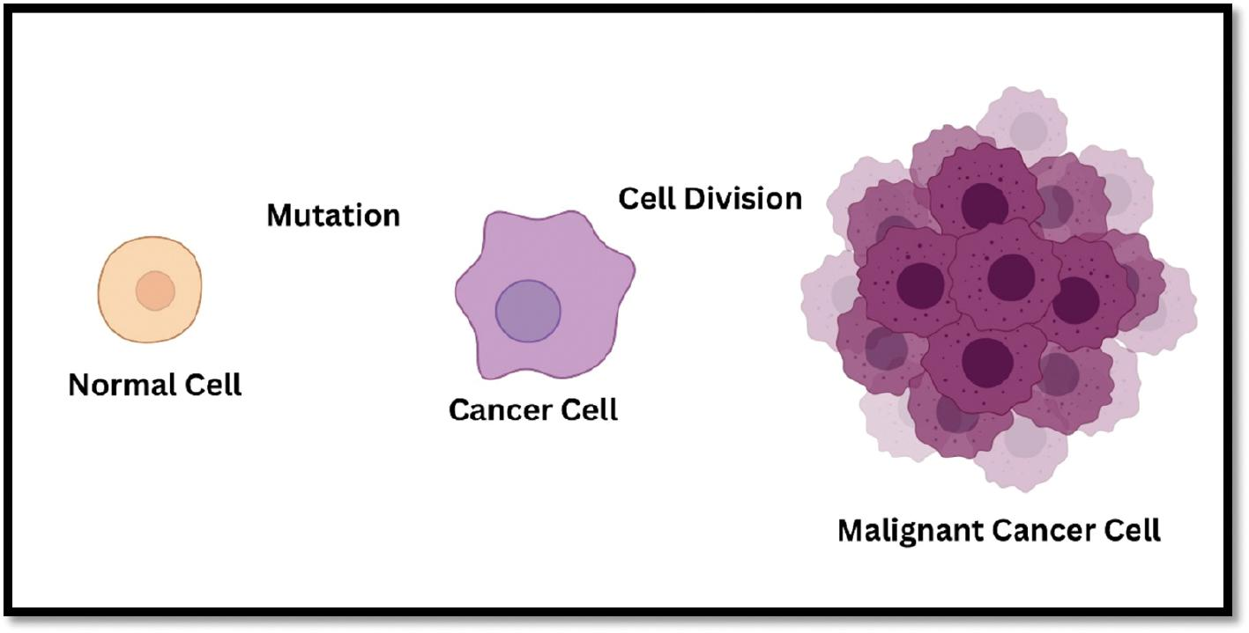

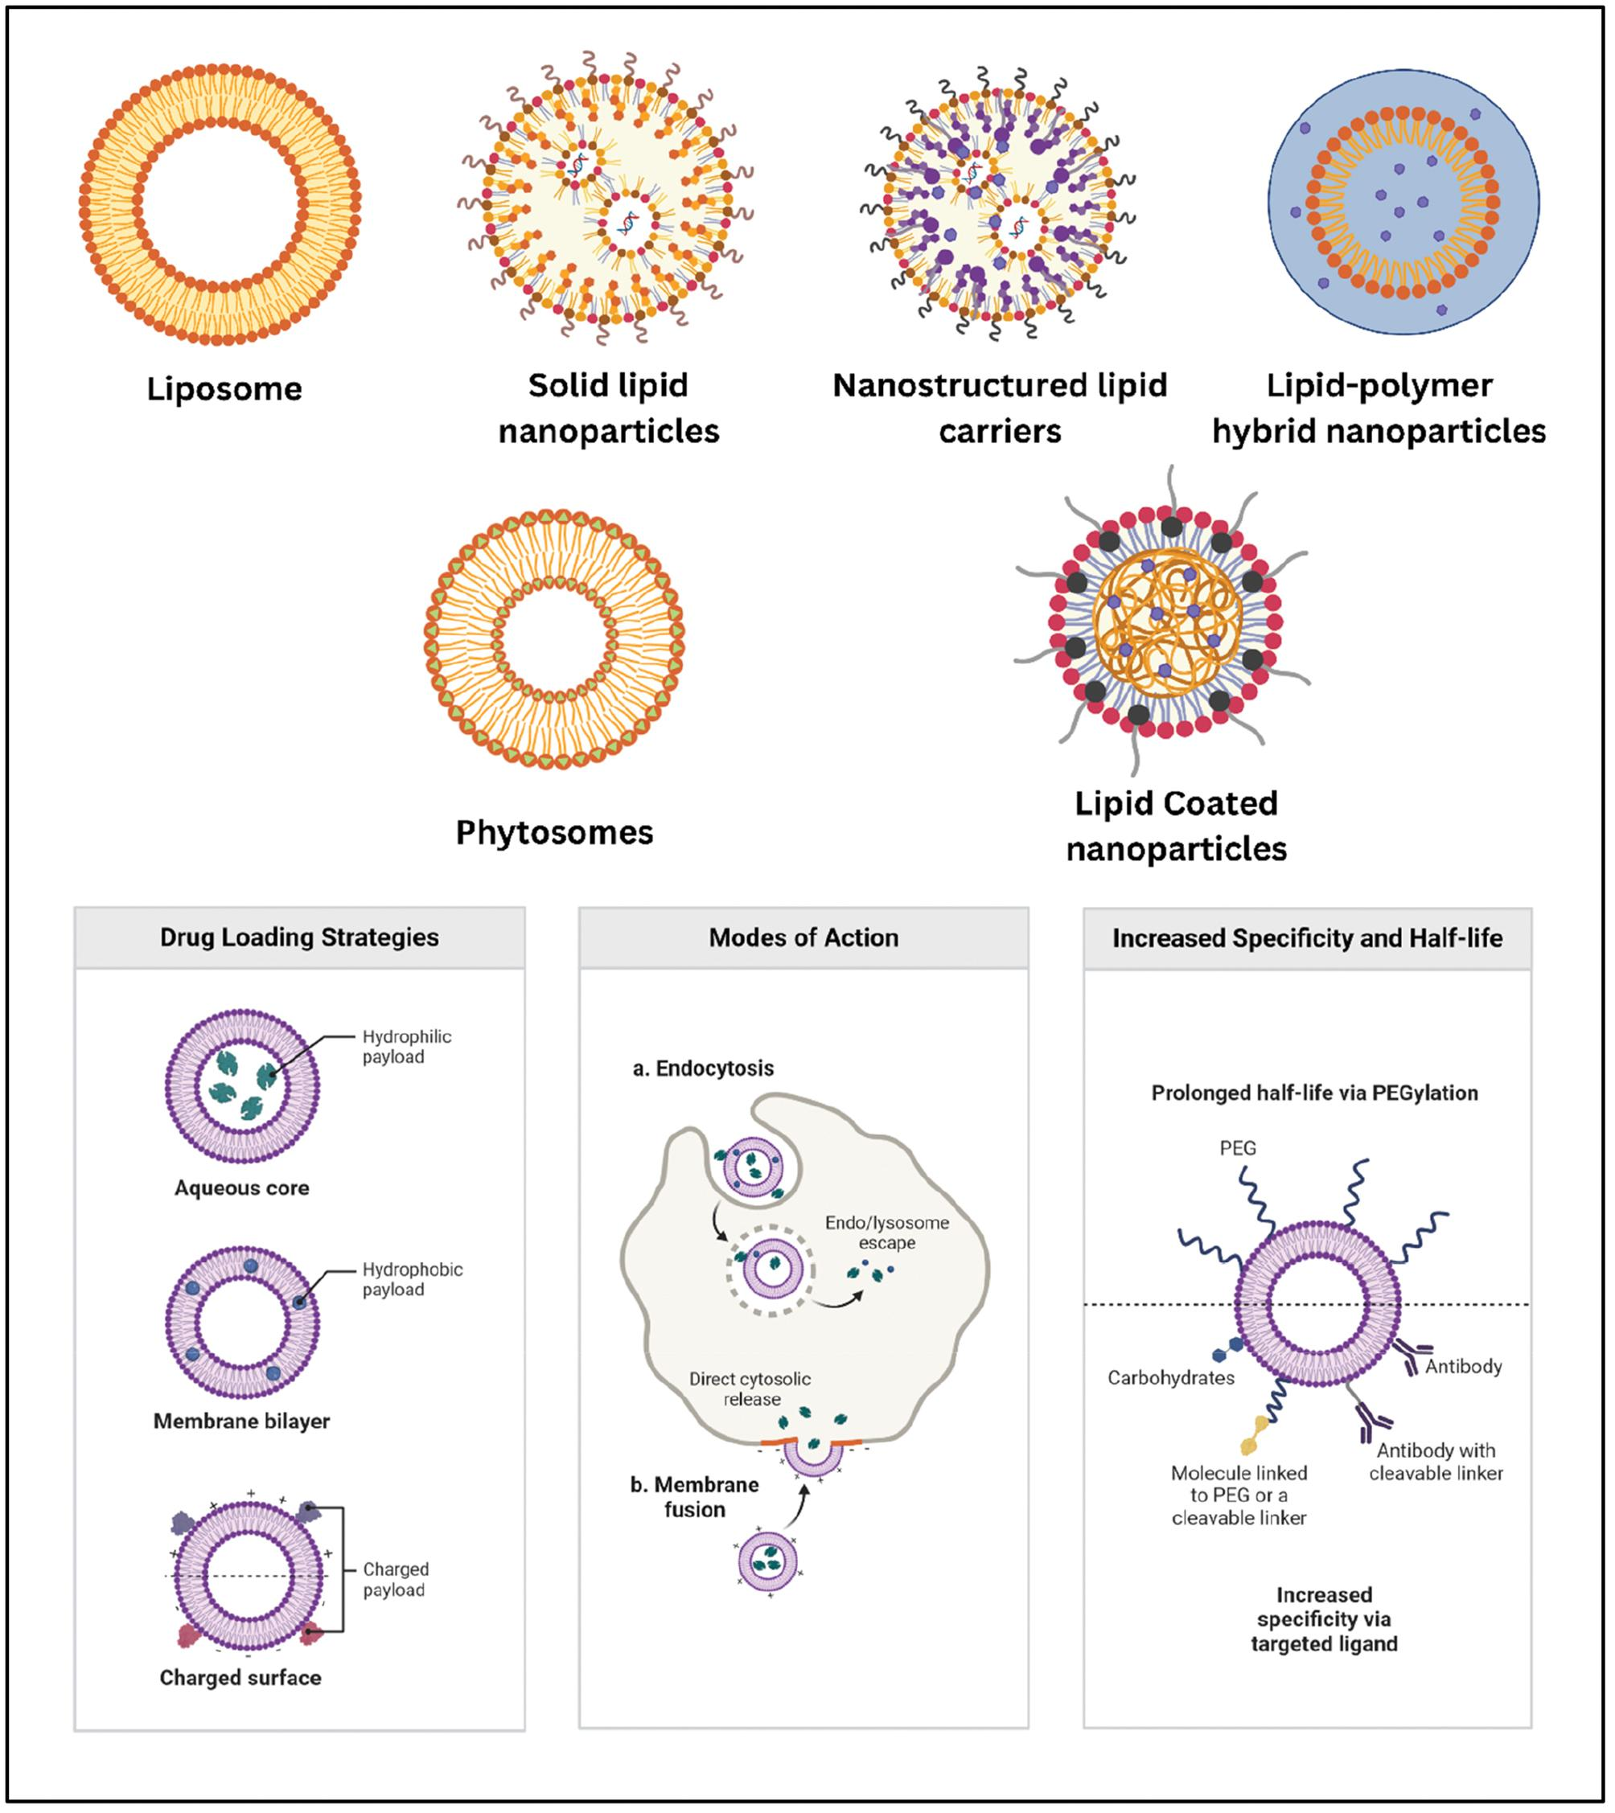

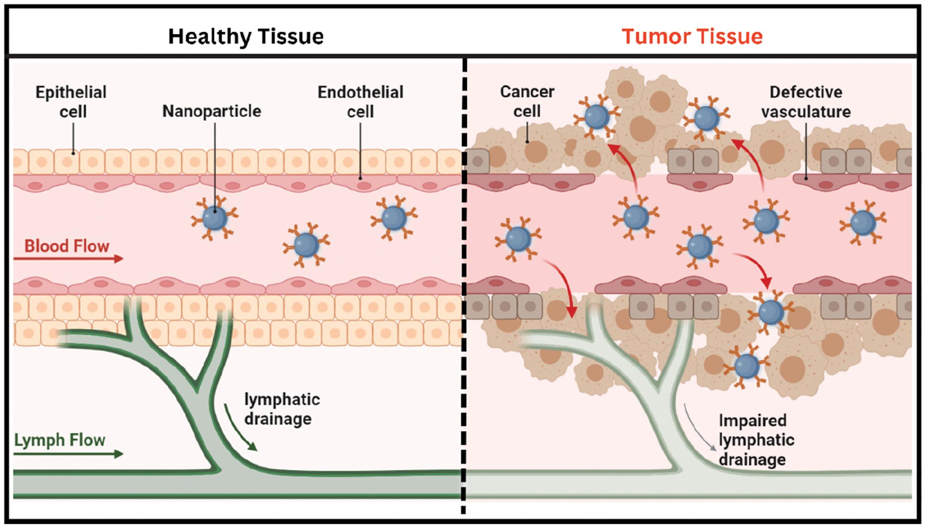

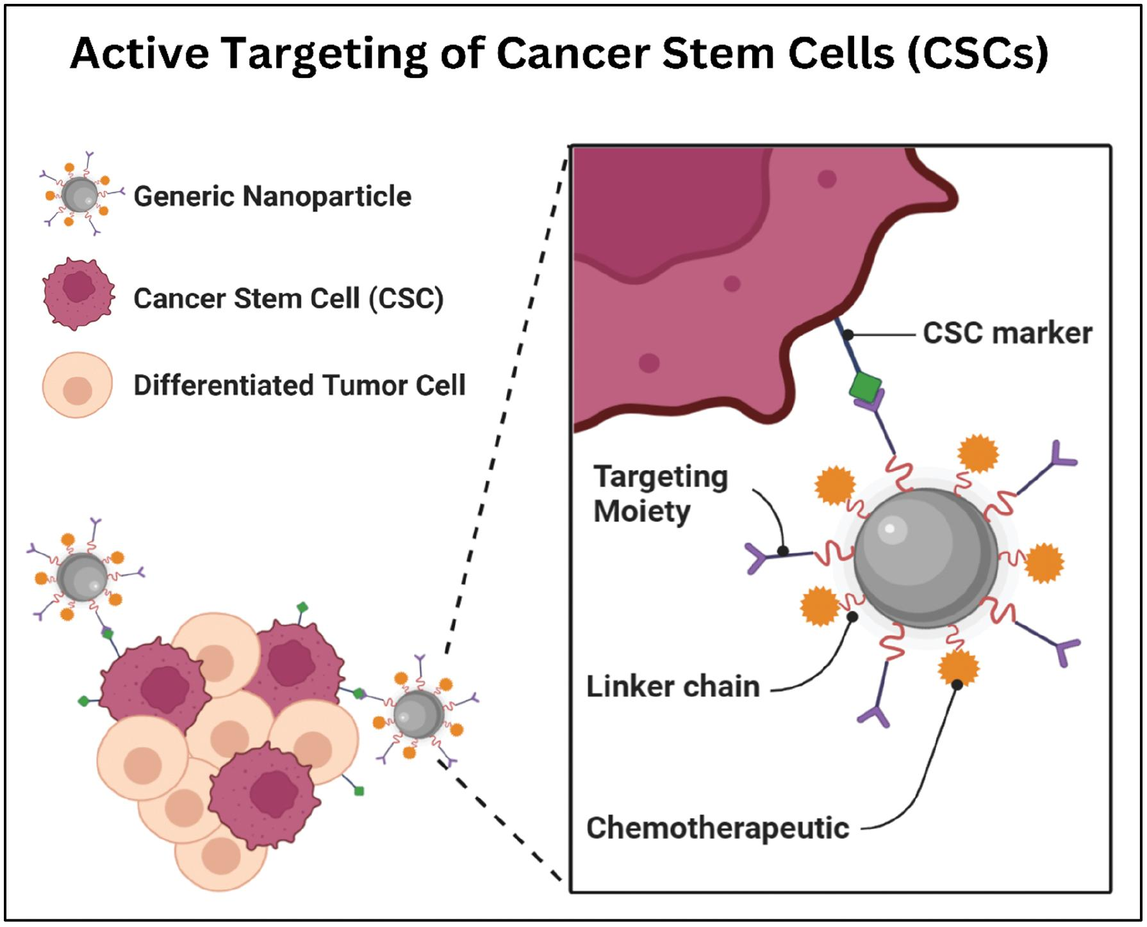

<https://www.scienceopen.com/hosted-document?doi=10.15212/bioi-2024-0107>

LNPs are spherical with an average diameter between 10 and 1000 nanometres. Whilst used for drug payloads (particularly useful for poorly water-soluble drugs), nucleic adic carrying is just as popular. The current understanding is that nucleic acid LNP’s with ionizable cationic lipids enter cells through the receptor-mediated endocytosis and end up inside endosomes. The acidity inside the endosomes cause LNP’s ionisable cationic lipids to acquire a positive charge and this it thought to allow LNPs to escape from endosomes and release their RNA payloads. It was in the 2010s that mRNA transport was used, later developed in 2020 for the SARS-CoV-2 use.

<https://www.mdpi.com/1999-4923/15/4/1053>

Cationic ioniizable lipids with pKa values below 7 are used to load anionic cargo, such as nucleic acis, at pH values below 7. They are usually linked together by carbon lipid tails. Under normal physiological pH conditions, the complex remains neutral until it is introduced to the lower pH of 5-6 inside the endosome. This causes proonation of the cationinc ionizable lipids in the endosome facilitates disruption of the endosomal membrane and subsequent carho release into the cytosol.

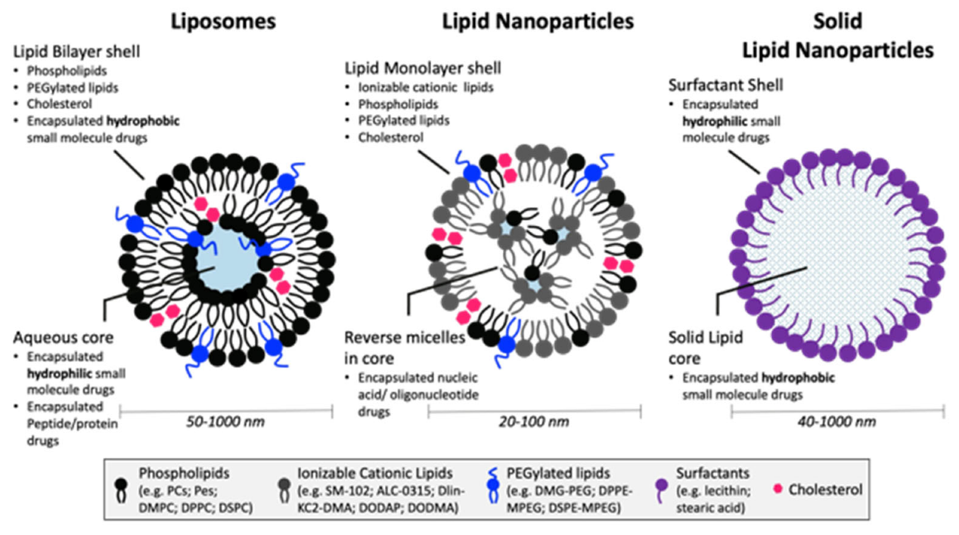

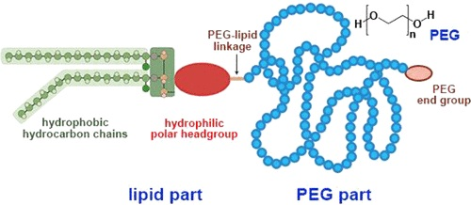

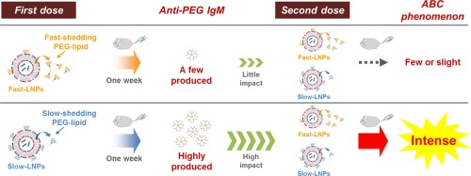

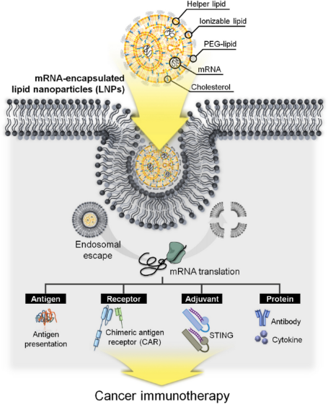 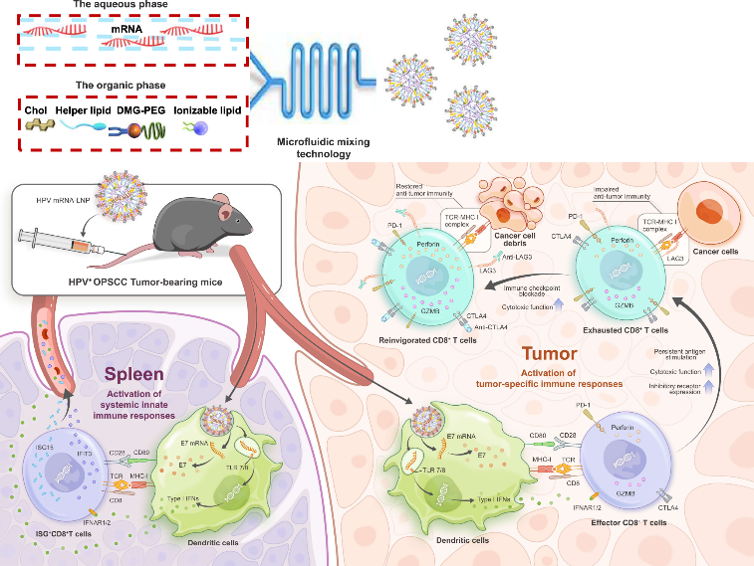

### In Detail – The Role of Four (Ionisable) Lipid Components of LNPs

<https://www.biochempeg.com/article/362.html>

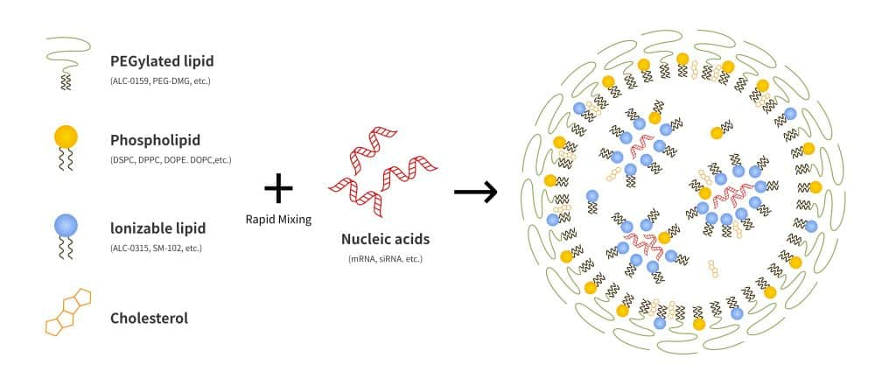

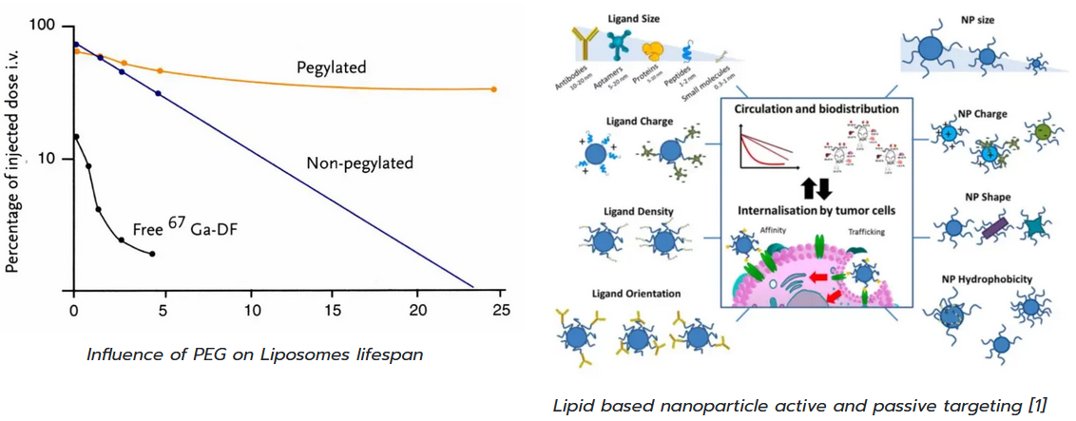

<https://insidetx.com/review/what-are-lipid-based-nanoparticles/>

LNP’s are composed of four main lipid types, each serving distinct roles related to stability, efficacy and safety.

Ionisable Cationic Lipids have pKa values (approx. 6.0-7.0), allowing them to be positively charged in acidic environments (enabling nucleic acid encapsulation and endosomal escape) but neutral at physiological pH to reduce toxicity. They prevent rapud clearance and reduce side effects compared to permantly charged cationic lipids Structurally, they have ionisable head groups, linkers and hydrophobic tails, with variations designed to enhance potency and targeting. Examples include FDA-approved MC3, SM-102 and ALC-0315

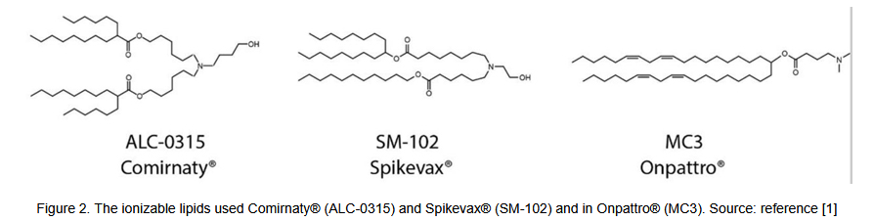

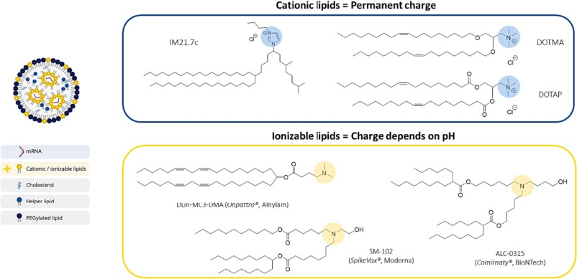

Phospholipids (Helper Lipids) stabilise the lipid nanoparticle structure and aid endosomal escape. DSPC (a saturated phosphatidylcholine) provides membrane stability but can limit endosomal fusion, while DOPE (unsaturated) promotes membrane fusion and nucleic acid release due to its flexible, fusogenic nature. Additionally, Cholesterol improves membrane integrity and fluidity, reducing leakage and prolonging circulation half-life. It balances lipid membrane properties to maintain nanoparticles stability and enhance encapsulation effectiveness.

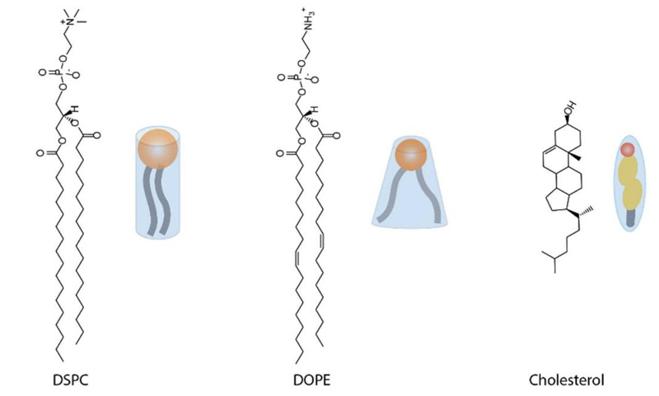

PEGylated Lipids (PEG-lipids) influence particle size, reduce aggregation and extend circulation time by reducing clearance by the immune system whilst facilitating ligan conjugation for targeted delivery. However PEG can reduce cellular uptake (“PEG dilemma”) and trigger immune reactions like ABC phenomena and Complement Activation-Related Pseudoallergy (CARPA). PEG length, density, structure and lipid linkage chemically affect immunogenicity and efficacy, necessitating optimisation for safe and effective formulations.

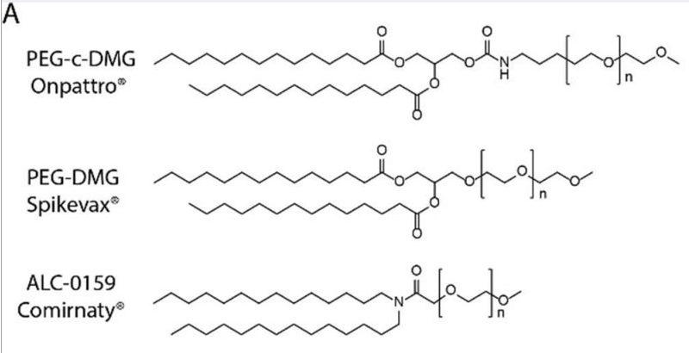

### LNP Synthesis

Aim – avoid high polydispersity, batch-to-batch and operator-dependent variability, and limits to the production volume.

High shear homogenisaiton -

Ultrasound – able to obtain size distribution within the range of 30-180 nm with ultrasonication at the cost of long sonication times.

Solvent emulsification/evaporation or microemulsion – appropriate in preparing small, homogeneously sized lipid nanoparticles dispersions with the advantage of avoiding heat.

Hot-homogenisation – production of carvedilol-loaded Solid Lipid Nanoparticles (SLN) for oral delivery

Others include phase inversion temperature, membrane conracr, coacervation and supercritical fluid-based methods. These methods rely on self formation of LBNPs followed by extrusion through a porous filter, reducing the yielf and increase production costs. Traditional methods seem to result in polydispersity with high batch-to-batch variability. Additionally, these manufacturing methods are apparently difficult to scale up past the mili-litre volume range. An example was Doxil or Myocet

Final quality control – testing polydispersity, particle size, drug loading efficiency and endotoxin levels

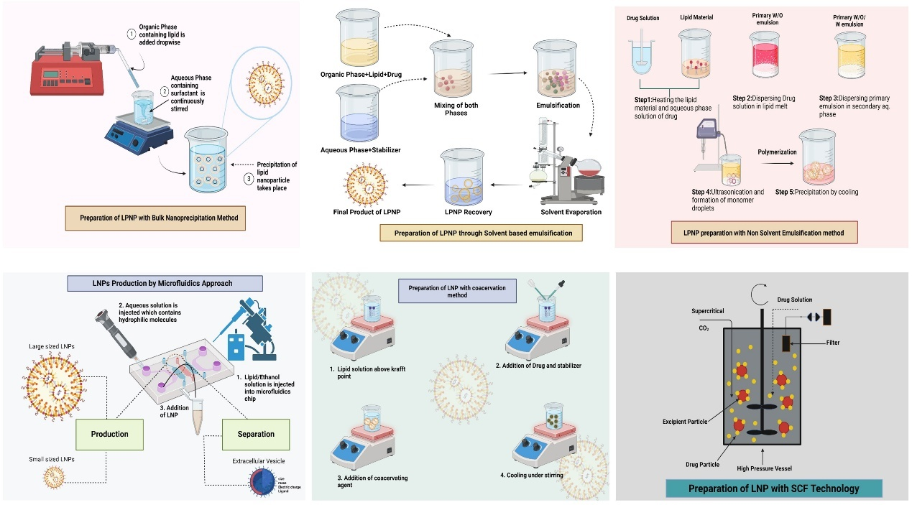

<https://www.frontiersin.org/journals/oncology/articles/10.3389/fonc.2024.1296091/full>

<https://www.scienceopen.com/hosted-document?doi=10.15212/bioi-2024-0107>

### Market Drugs of Lipid-based Nanoparticles (LBNPs)

Doxil or Myocet

* 1995
* Doxorubicin HCL liposome injection, a chemotherapy drug
* It is a liposome formulation, meaning the drug is encapsulated within liposomes
* The encapsulation allows for target delivery of to cancer cells, helping to reduce some of the side effects associated with traditional chemotherapy.
* 2011, FDa suspended Doxil manufacturing when the company failed to cmply with GMP’s likely due to complicate production process

Onpattro or Patisiran

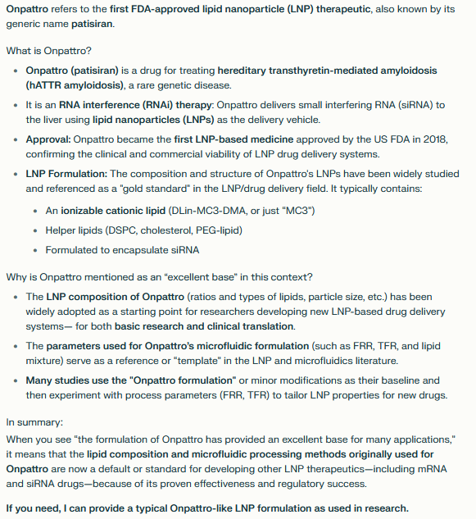

### Production of LBNPs Using Microfluidics

<https://www.mdpi.com/1999-4923/15/4/1053#B23-pharmaceutics-15-01053>

The optimal LBNP size is based on the target cell and the rout of administration. Literature points towards smaller sized LNPs (<100n) are needed when targeting tumors or the lymphatic system; larger (200-500nm) used for targeting dendritic cells for delivering mRNa to dendritic cells (DCs) for vaccination and immunotherapy.

Important microfluidic conditions to consider include the micromixer geometry, total flow rate (TFR), flow rate ratio (FRR) and lipid concentration Generally, high TFR, FRR and low lipid concentration produce smaller-sized LNPs. The effect of micromixer geometry is less defined as it can be case-dependent, but those tht induce rapid mixing are preferrable for the production of smaller LBNPs. This is because rapid and chaotic mixing allow for faster diffusion and solvent exchange between streams. Rapid solvent exchange increases the rate of supersaturation, leading to fast nucleation and the creation of smaller, more uniform LNPs. Low FRR favours slower mixing, allowing particles to grow larger before being stabilised. A lower lipid input concentration leads to fewer available lipids molecules in the solvent. Resultingly nanoparticle growth is limited, favouring the formation of smaller particles.

#### Commercial examples

Precision Nano-system’s instruments are equipped with bifurcating mixers

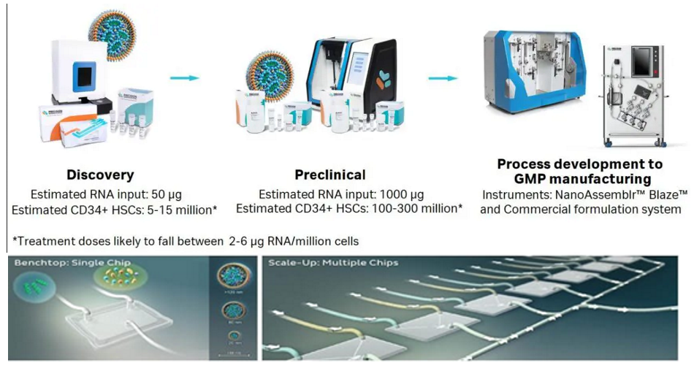

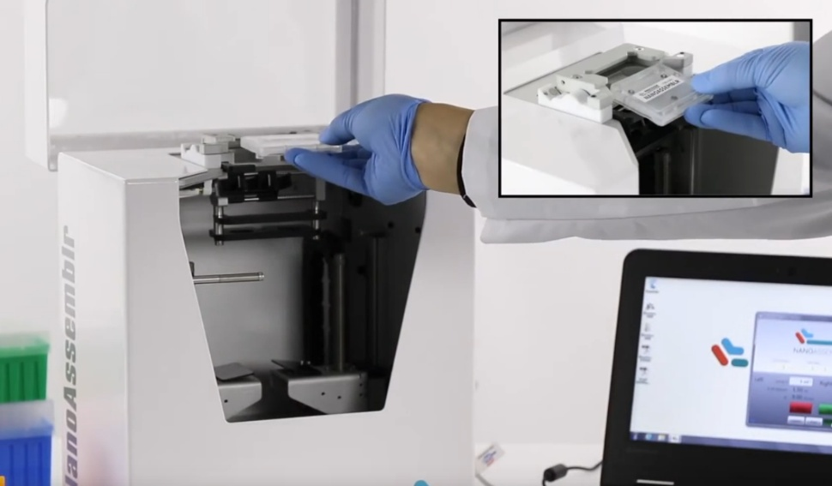

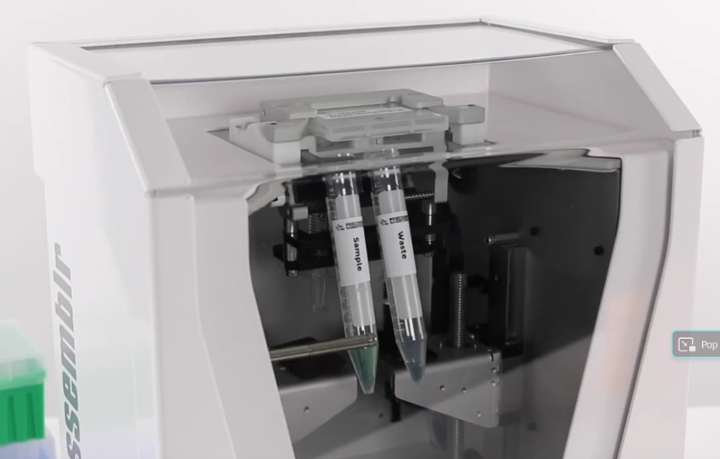

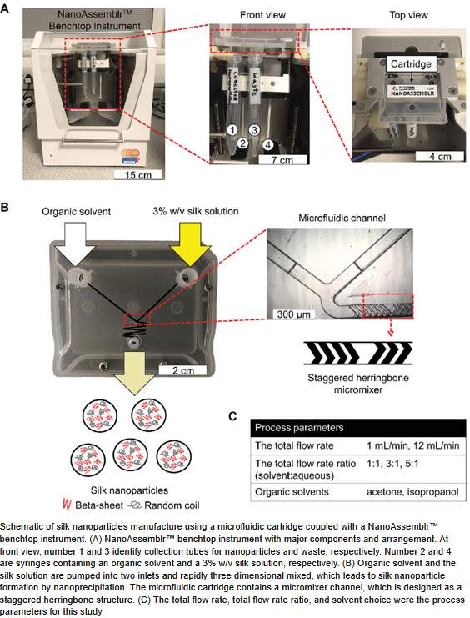

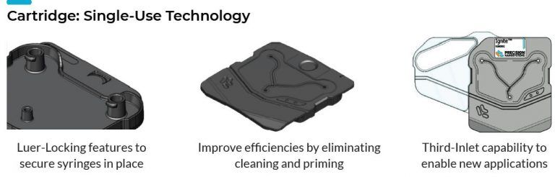

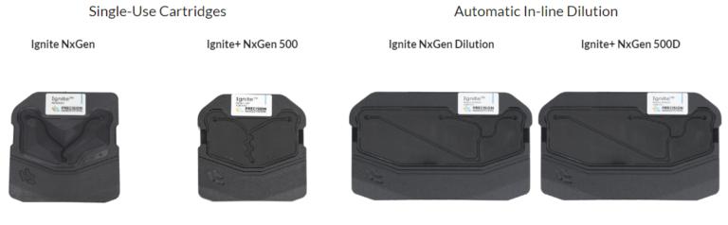

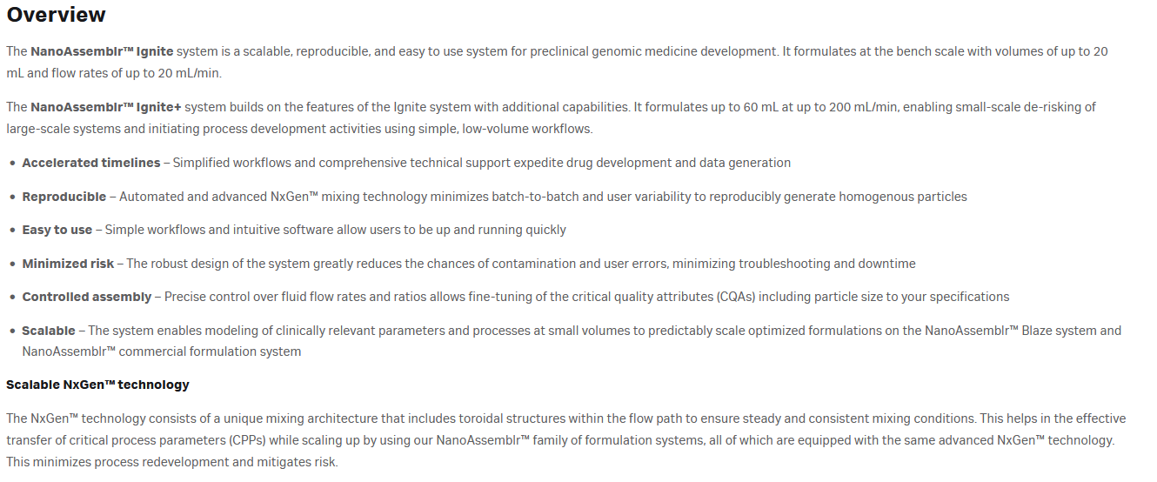

<https://www.cytivalifesciences.com/en/us/shop/lipid-nanoparticle-instruments-and-reagents/nanoparticle-formulation-cartridges-and-flow-kits/nanoassemblr-ignite-cartridges-p-45321>

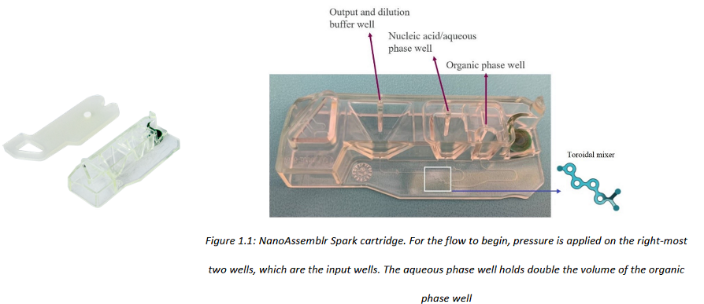

<https://me.jhu.edu/wp-content/uploads/2024/09/Microfluidics-Sample-Essay.pdf> --> COMSOL SIMULATIONS

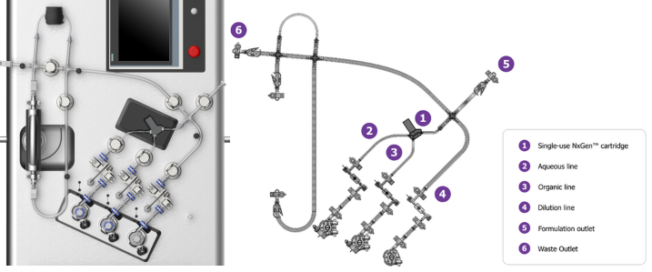

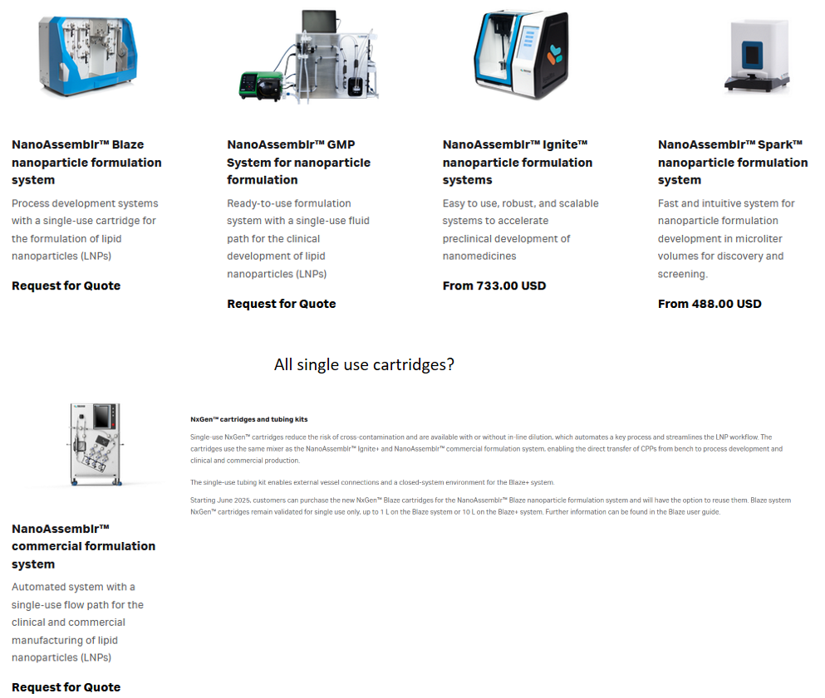

<https://www.cytivalifesciences.com/en/us/shop/lipid-nanoparticle-instruments-and-reagents/nanoparticle-formulation-systems?sort=NameAsc&chunk=1>

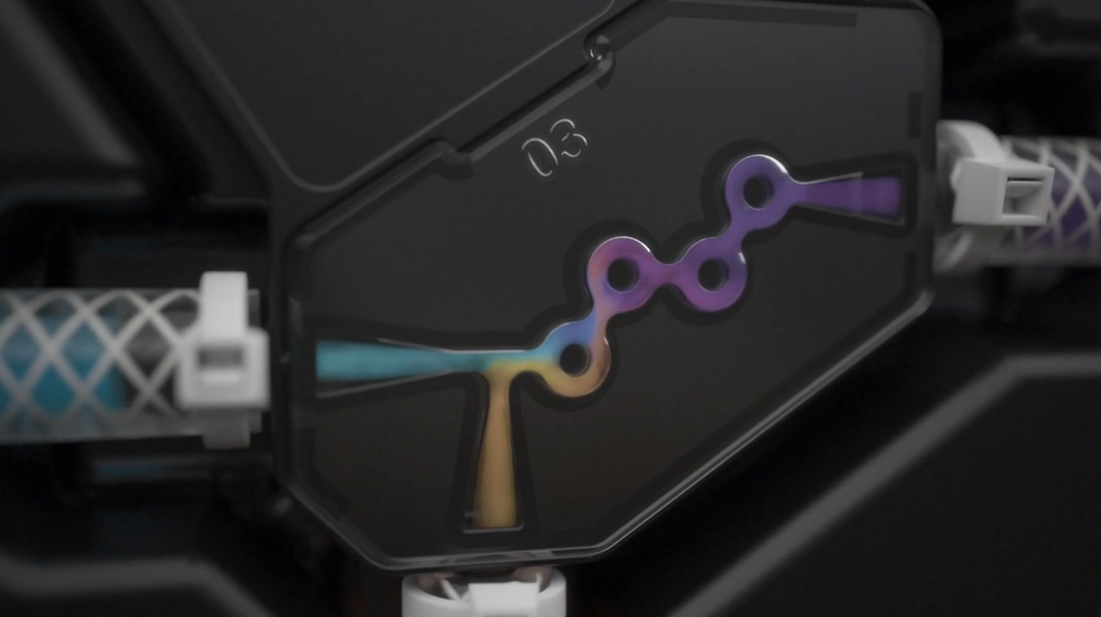

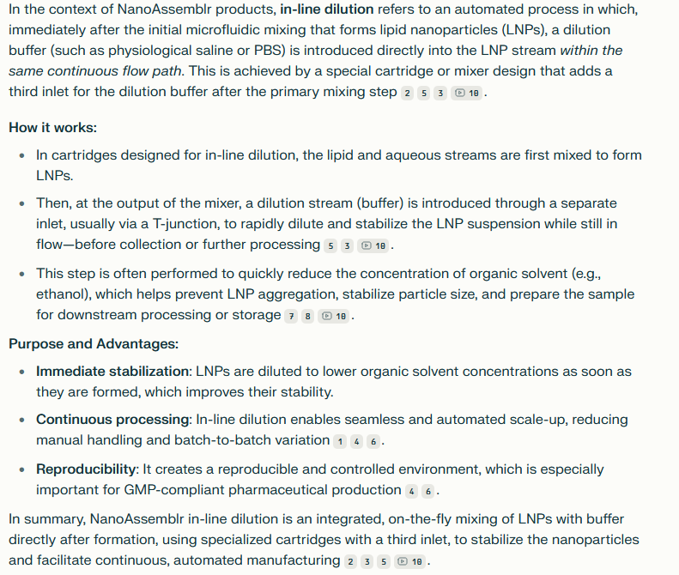

Lilac Pharma commercially available nanoparticle production device, iLiNP, contains a baffle mixer. Its whown to beable to control LNP size from 20-100nm in 10 nm increments, compared to a chaotic mixer. Smaller LNPs were homogenously produced using higher TFR and FRR values and lower lipid concentratios.

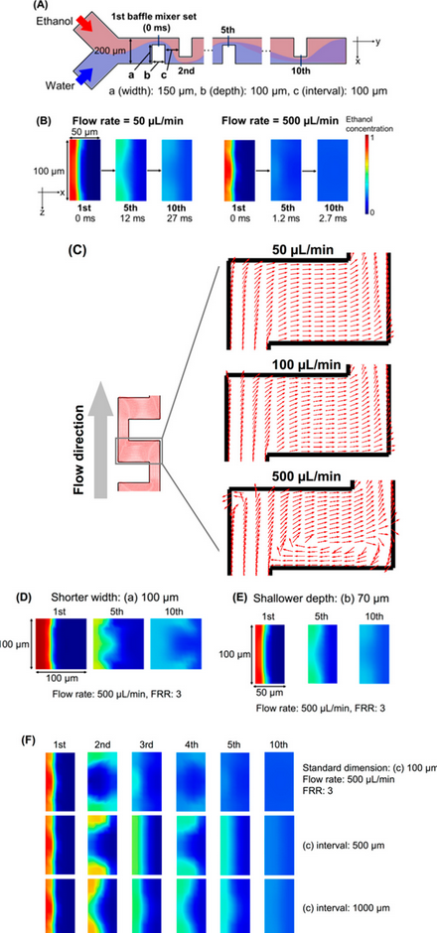

<https://pubs.acs.org/doi/full/10.1021/acsomega.8b00341> [CHECK THIS PAPER FOR CFD]

Similar trends were seen using a staggered herringbone mixer (SHM), but with particle sizes ranging from 3-80nm

However these two solutions could not create larger-size LNPs homogeneously/with a low polydispersity index. To combat this, a 3D-iLiNP, which was able to achieve a 102 nm particle.

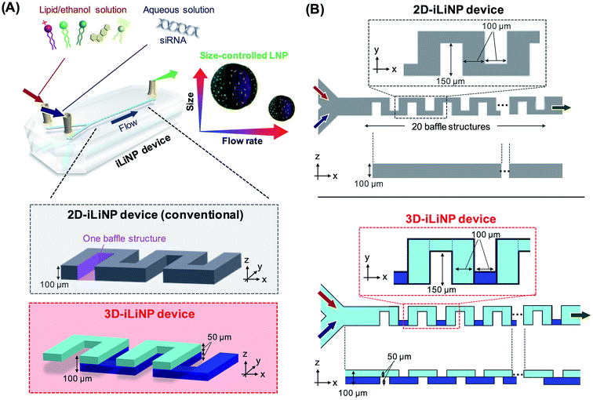

Interestingly, one literature example used too little lipid concentration, which lowered the had a negative effect on the transfection efficiency, as there is less lipid to bind the mRNA at higher loadings. Additionally, this paper highlight an interesting discussion. They use microfluidics to create 175nm and batch method for 226nm LNPs. The key advantage of microfluidics is its ability to narrow size distribution (PDI) and reproducibility. One can generate LNPs >100nm by [1] Increasing input lipid concentration, [2] Lower FRR, [3] Reduce TFR, [4] Adjust mixing geometries and temperature. Which begs the question why batch is used in industry, if it even is!? <https://www.cell.com/molecular-therapy-family/nucleic-acids/fulltext/S2162-2531(19)30017-4> Continuing with producing larger LNPs, this paper explored the effect of TFR, FRR, buffer pH, lipid concentration, molar ration of PEG and sal concetration on particle size greater than the typical 30-100nm particles produced by microfluidics, using an iLiNP device to be exact. They found that the simple addition of salt, e.g. NaCl to a buffer containing nucleic acids contributed greatly to the synthesis of large LNPS over 200nm. <https://www.sciencedirect.com/science/article/abs/pii/S0168365922003467>

One particularly interesting paper used NxGen toroidal micromixer to investigate size, uniformity and Encapsulation Efficiency (EE) of LNP’s encapsulating a GFP plasmid. They found a plateu and window of process parameters (TFR>=4 mL/min and FRR >3) where you can reliably make LNPs that are approx. 100nm diameter, Low PDI with high EE (approx. up to 80% of plasmid payload). This simply means that 80% of the plasmid DNA was encapsulated and 20% was left in the solution/didn’t get captured (this is EE). The papers plateau design is a good example of designing optimised mixers, as once it plateaus, other factors such as lipid type/concentration, nucleic adic payload, buffer composition or post-processing can be focused on. Ultimatly, with this mixer and parameters, increasing TFR and FRR increases mixing speed, which shrinks LNP sizes and boosts EE up to a certain threshold. <https://www.nature.com/articles/s41598-022-13112-5>

Why can’t you just have a large tube, with nanoscale mixers through its length – will this not be efficient mixing?

Another paper used compared microfluidic chips, automated by Dolomite microfluidic system, with typical thin film hydration; finding the microfluidics used significantly lower Dox and lipid inputs, the liposomes were more homogeneous in size and shape and introduced higher toxicity to the breast cancer cells at a lower concentration. <https://www.sciencedirect.com/science/article/abs/pii/S037851732030911X>

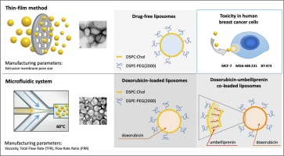 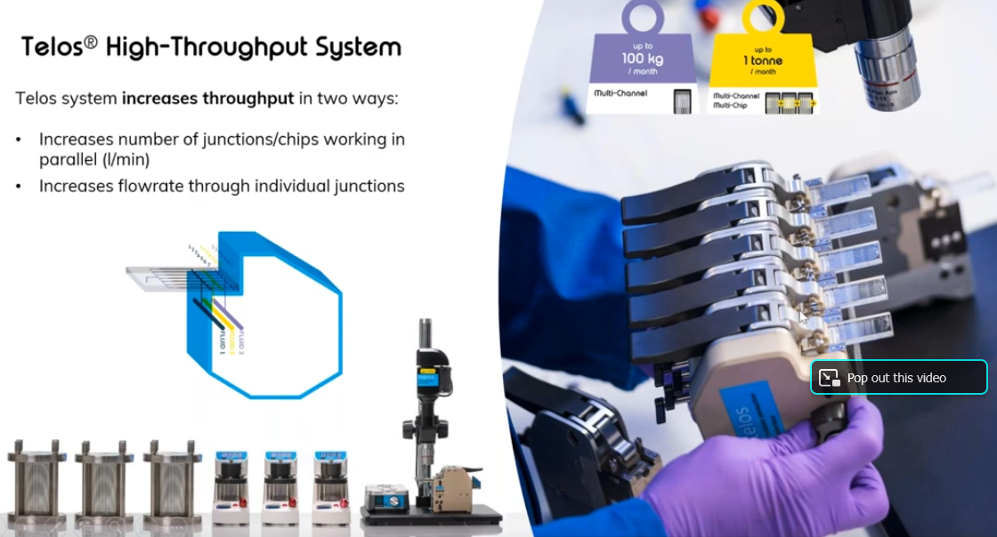

<https://www.youtube.com/watch?v=PUaYT6B5TRo>

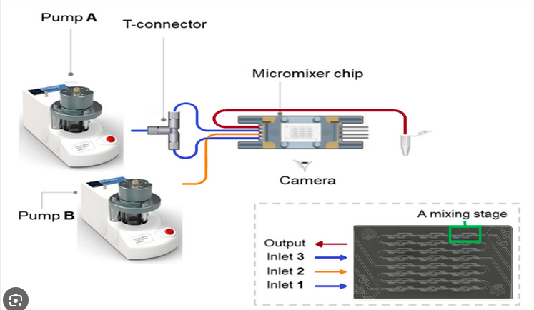 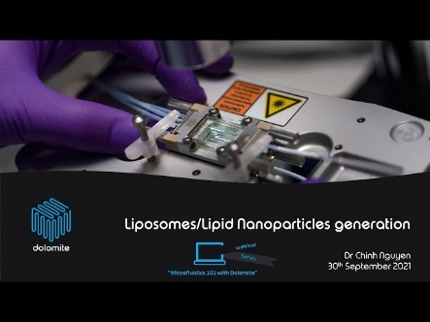

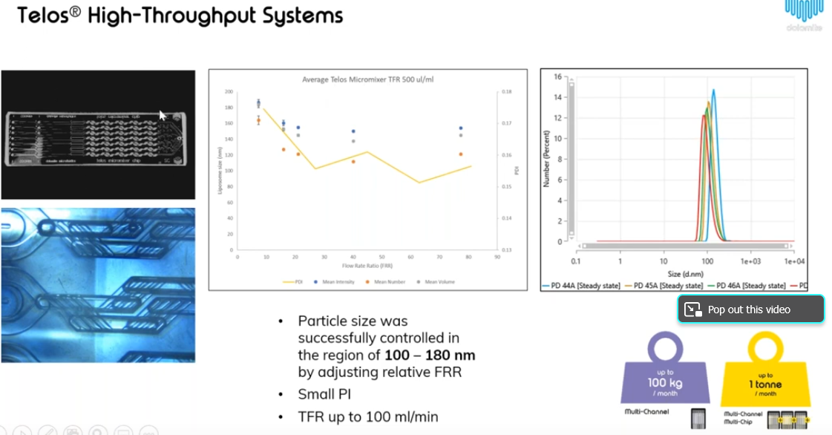

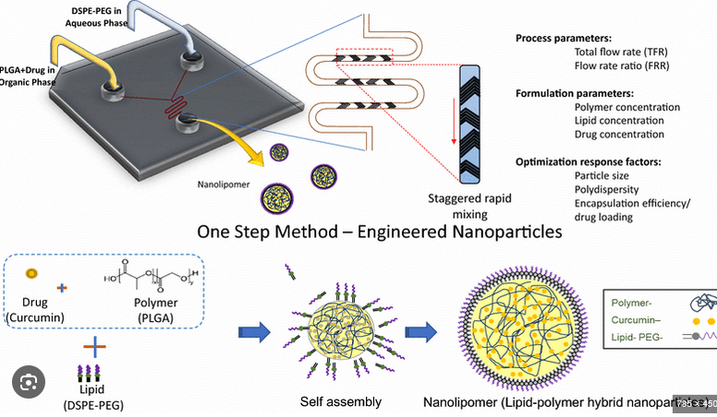

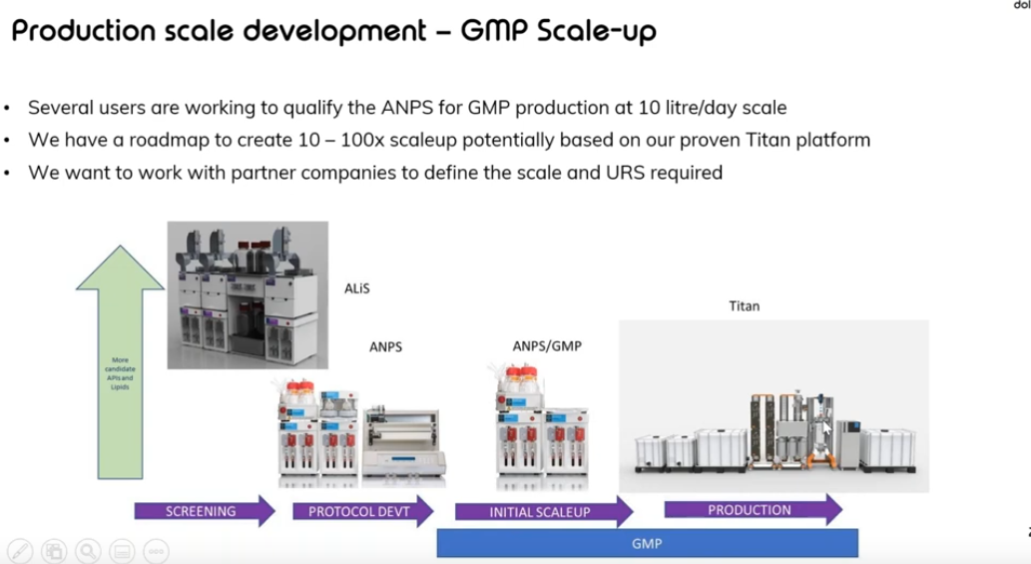

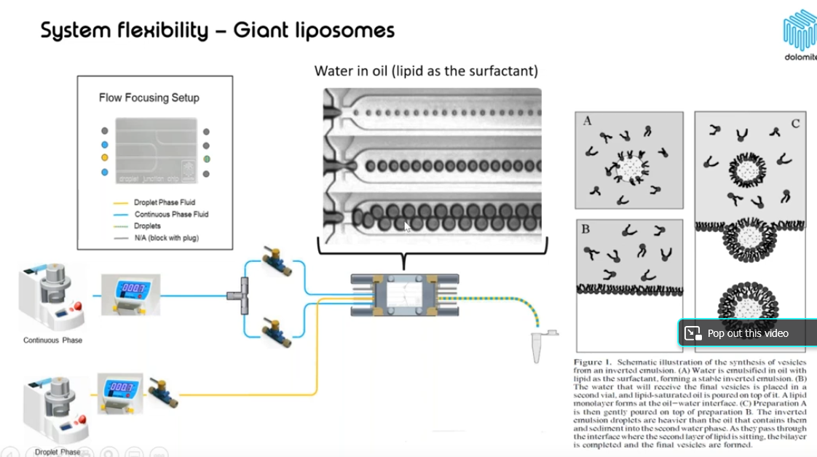

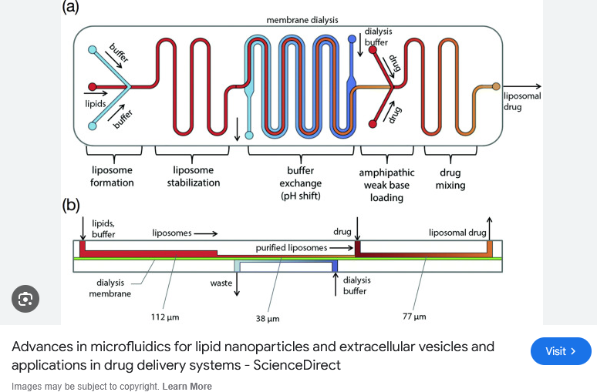

“Optimal micromixer geometry can be case-dependent, requiring arduous optimisation studies … swirl mixers are used to prevent clogging if aggragates form”

# Possible Plan

Aim: Increase the throughput of a flexible LNP system

1. NanoAssemblr Platform with:
   1. OEM product
   2. Own designed and manufactured chip
2. Dolomite Telos with laddered and numbered-out chip
   1. Type of chip leans towards iLiNP
3. What about large LNPs? Could be a future development with second channel or alternative slide/chip

# Papers

## CFD Benchmark & Throughput Experiment

….

## Miscellaneous

<https://www.mdpi.com/1999-4923/12/11/1095>

<https://www.sciencedirect.com/science/article/abs/pii/S0378517322003179>

<https://www.nature.com/articles/s41392-022-00950-y>

<https://www.sciencedirect.com/science/article/pii/S0168365921001541#f0015>

<https://www.sumitomoriko.co.jp/english/news/2020/20200821_01.html>

<https://global.lilacpharma.com/eng/ilinp_technology_eng/>

<https://global.lilacpharma.com/eng/ilinp_technology_eng/>

<https://www.nature.com/articles/s41598-022-12100-z>

<https://insidetx.com/review/what-are-lipid-based-nanoparticles/>

<https://www.frontiersin.org/journals/oncology/articles/10.3389/fonc.2024.1296091/full>

<https://www.frontiersin.org/files/Articles/1296091/fonc-14-1296091-HTML/image_m/fonc-14-1296091-g003.jpg>

<https://www.scienceopen.com/hosted-document?doi=10.15212/bioi-2024-0107>

<https://www.atascientific.com.au/next-generation-lnp-manufacturing/>

<https://mitchell-lab.seas.upenn.edu/wp-content/uploads/2025/01/ACSNano_Hwang.pdf>

<https://www.pnas.org/doi/10.1073/pnas.2303567120>

<https://www.sciencedirect.com/science/article/pii/S2352940723000240>

<https://pubs.rsc.org/en/content/articlehtml/2023/ma/d3ma00021d>

<https://www.helixbiotech.com/post/turbulent-mixing-scaling-up-nanoparticle-manufacturing-for-the-future>

<https://www.sciencedirect.com/science/article/abs/pii/S0378517320302507>

<https://global.lilacpharma.com/eng/ilinp_technology_eng/>

<https://www.sciencedirect.com/science/article/pii/S2352940723000240>

<https://pubs.acs.org/doi/10.1021/acsomega.8b00341>

<https://www.youtube.com/watch?v=CeEJS1eT9NE>

<https://www.comsol.com/blogs/using-simulation-to-guide-mrna-vaccine-production>

<https://www.comsol.com/video/keynote-simulating-lipid-nanoparticle-self-assembly-for-mrna-vaccine-production>

<https://www.youtube.com/watch?v=KznljrgWSvo>